**A452 Java Script**

**William Wood**

**7474**

**For June 2017**

**Task 1:**

**My plan for completing task 1:**

I am going to start by reading through the task. Then I’m going to copy the code into Dreamweaver and run it to make sure it works. If there are any errors then I’m going take remedial action and run it again. I’m also going to explain how I ran the script and explain each line.

**Success Criteria**

**-**I will copy the code in to my IDE (Macromedia Dreamweaver) without error.

**-**I must make sure that the code displays the right text on the initial run.

**-**I must make sure that when the "Click Me!" button is pressed the "Now you see me." paragraph changes to "Gone!".

**-**I must make sure that when the "Bring me back!" button is pressed the paragraph changes to "Back again"

**-**I must make sure that my code works in the web browsers Google Chrome and Internet Explorer.

**A screen shot of script that I have entered:**

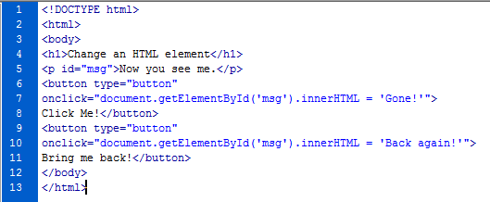

**Evidence of the code running:**

Initial run:

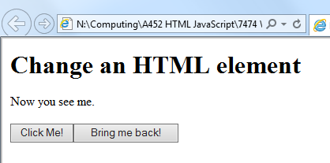

When the “Click Me!” button is clicked, the text changes from “Now you see me.” to “Gone!”:

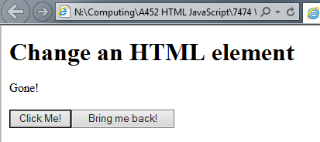

When the “Bring me back!” button is clicked, the text text changes from “Gone!” or “Now you see me.” to “Back again!”:

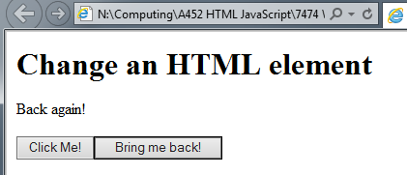

**Testing of the code in different browsers:**

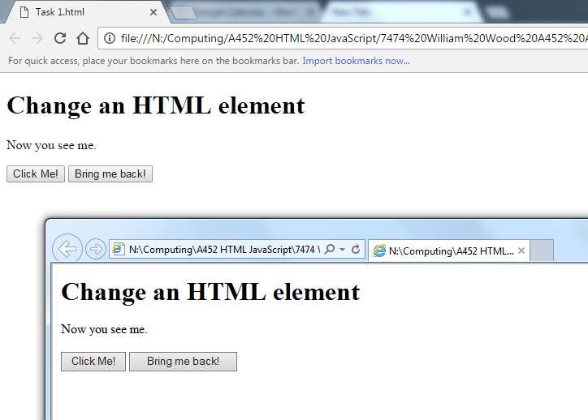

This image shows the the code runs correctly in the 2 browsers, Google Chrome and Internet Explorer.

**Evidence of remedial action taken to correct errors in the code:**

The code ran perfectly first time so I didn’t need to take any remedial action.

**An explanation of how you ran the code (Add any sources of additional information you may have researched):**

I copied the code into Dreamweaver and pressed F12 to open the code in the web browser. The web browser fetches the page from the file then because the JavaScript is waiting for an event (onClick) it does not do anything until either buttons are pressed. The HTML runs one line at a time so the header is loaded first, then the heading, then the paragraph, the buttons and finally the JavaScript.

(Source: [http://www.makeuseof.com/tag/what-is-JavaScript-how-works/](http://www.makeuseof.com/tag/what-is-javascript-how-works/) )

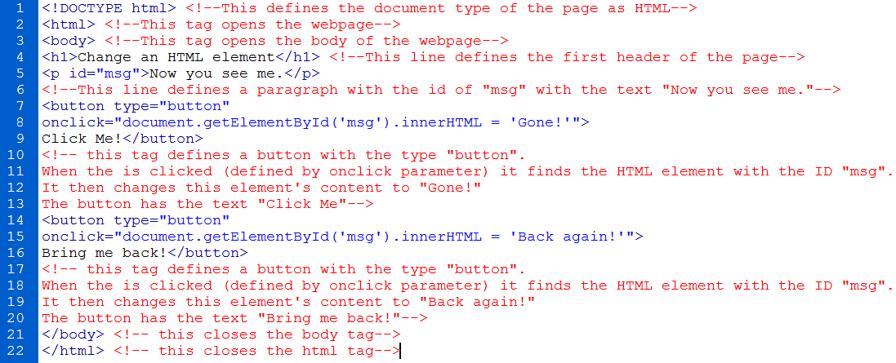**Annotation of the code**

I annotated all of my HTML code using the comment tags **<!--** and **-->**. This makes it easy for other people to see what each line of the code does in detail. This also helps with troubleshooting as you can clearly see what each tag does and how it works.

**Evaluation against the success criteria:**

|  |  |  |
| --- | --- | --- |
| Criteria Point | How The Criteria Point Has Been Met | Evidence |
| I will copy the code in to my IDE (Macromedia Dreamweaver) without error. | I copied the code into Dreamweaver and the code ran perfectly first time with no errors |  |
| I must make sure that the code displays the right text on the initial run. | When I ran the code there was no errors and the code displayed the correct text and buttons on the webpage. |  |
| I must make sure that when the "Click Me!" button is pressed the "Now you see me." paragraph changes to "Gone!". | The JavaScript buttons work when they are clicked (shown in YELLOW) and the text changes to "Gone!" (shown in RED) |  |
| I must make sure that when the "Bring me back!" button is pressed the paragraph changes to "Back again" | The JavaScript buttons work when they are clicked (shown in YELLOW) and the text changes to "Back Again" (shown in RED) |  |
| I must make sure that my code works in the web browsers Google Chrome and Internet Explorer. | When I ran the code in the two different web browsers, I found that it works perfectly |  |